# Regression Analysis Practical 6

## 1) Problem Statement

## Assignment on Regression technique.

## Download temperature data from the link below.

## https://www.kaggle.com/venky73/temperaturesof-india?select=temperatures.csv

## This data consists of temperatures of INDIA averaging the temperatures of all place’s month wise. Temperatures values are recorded in CELSIUS.

## a) Apply Linear Regression using a suitable library function and predict the Month-wise temperature.

## b) Assess the performance of regression models using MSE, MAE and R-Square metrics

## c) Visualize a simple regression model.

## 2) Libraries Used

Python:  
Pandas: For data manipulation and analysis.  
Matplotlib: For creating visualizations.  
Scikit-learn: For implementing the linear regression model and computing performance metrics.

## 3) Theory

Linear regression is a statistical method for modelling the relationship between a dependent variable and one or more independent variables by fitting a linear equation to observed data. The method provides a measure of how well future outcomes are likely to be predicted by the model.

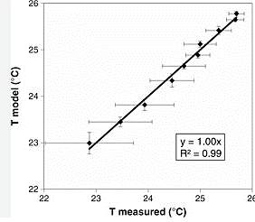

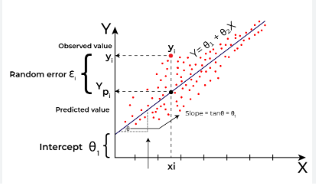

## 4) Methods

The method involves preparing the data, fitting a linear regression model, predicting temperature values, and assessing the model's performance using metrics such as Mean Squared Error (MSE), Mean Absolute Error (MAE), and R-Squared (R²).

## 5) Advantages

Advantages of linear regression include:

* • Simplicity and interpretability of the model.
* • Efficiency in prediction of outcomes.
* • Well-studied, with extensive literature and applications in many fields.

## 6) Disadvantages

Disadvantages of linear regression include:

* • Assumes a linear relationship between the dependent and independent variables.
* • Can be overly sensitive to outliers.
* • Does not perform well when data relationships are non-linear without transformation.

## 7) Working

The regression analysis is conducted by initially exploring the data, then applying linear regression, and finally evaluating the model using specified performance metrics. The relationship between the years and temperatures is visualized to illustrate the model's fit.

## 8) Conclusion

The regression analysis effectively predicts temperature trends over years and assesses model performance, providing insights into the application of linear models in practical settings. The exercise demonstrates the utility of regression in understanding and forecasting trends.